Trigeminal Neuralgia: A Case Study Report
Student’s Name
Institutional Affiliation
Course Name
Instructor’s name
Date

Trigeminal Neuralgia: A case study report
Introduction
Trigeminal neuralgia is a condition defined as a sudden outburst of explosive pain in the area of distribution of the branches of trigeminal nerve,which is the cranial nerve V. This pain is brought about by certain factors called trigger factors. Some of the trigger factors are; talking, chewing, brushing of teeth, smiling, face touching, a wind breeze and shaving. There are 2 types of trigeminal neuralgia; classical trigeminal neuralgia and symptomatic trigeminal neuralgia(Truini, 2015)
Trigeminal neuralgia can be diagnosed by medical professionals through a series of neurological examinations to determine the branch of CN V that is affected and Magnetic Resonance Imaging which might reveal the underlying cause of the condition.
Case Report
Mrs. T, a 55 year old woman, came to the hospital complaining of sudden bursts of intense right-sided pain that usually resolved as quickly as it appeared. The outbursts of pain began 2 weeks ago and the frequency of the episodes had increased in the past week from 2-3 to 7 or more each day. This severe pain was triggered by certain activities and her VAS score was 5.(Yang et al, 2019)
A radiological investigation came out normal. The patient had no history of chronic diseases such as diabetes mellitus and hepatitis. An MRI test revealed a vascular compression of the cranial nerve by the superior cerebellar artery on the right side and a diagnosis of trigeminal neuralgia was made.
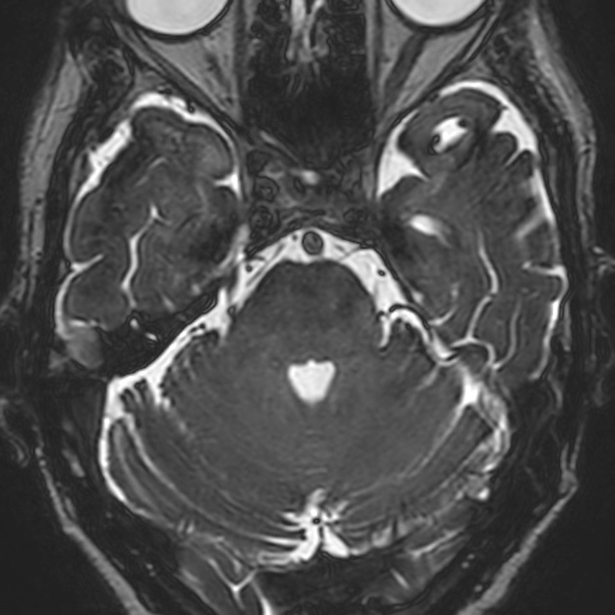
The right superior cerebellar artery loop is in contact with the right trigeminal nerve causing thinning of the nerve at this region. The left trigeminal nerve is normal.
The patient was started on oral medication of Carbamazepine (Equetro), 200 mg a day. After two months, at a check-up appointment, the patient reported a reduction in the frequency and intensity of pain episodes to a VAS score of 3(Delgado et al, 2018).However, a year later, the patient returned complaining of severe paroxysmal pain episodes that lasted a few minutes with a frequency of 20 or more each day. The medication was no longer effective. As a result, a microvascular decompression procedure was carried out to relieve the trigeminal nerve of compression by the superior cerebellar artery on the right side. After the operation, the patient’s symptoms resolved.
Findings
Oral medication is most preferred as a first-line of treatment for trigeminal neuralgia as it is not invasive, is cheaper and very effective.Patients could be prescribed with medications such as Carbamazepine (Equetro), Lioresal or Oxcarbazepine, which has fewer side effects compared to Carbamazepine (Equetro) In the case where oral medication is not effective, surgical interventions may be considered to relieve the trigeminal nerve of vascular compression.

References
Yang, X. H., Li, Y., Yang, L. Q., Wu, B. S., & Ni, J. X. (2019). Nerve coblation for treatment of trigeminal neuralgia: A case report. World journal of clinical cases, 7(9), 1060–1065. https://doi.org/10.12998/wjcc.v7.i9.1060
Truini A. (2015). Trigeminal neuralgia. The journal of headache and pain, 16(Suppl 1), A42. https://doi.org/10.1186/1129-2377-16-S1-A42
Delgado, D. A., Lambert, B. S., Boutris, N., McCulloch, P. C., Robbins, A. B., Moreno, M. R., & Harris, J. D. (2018). Validation of Digital Visual Analog Scale Pain Scoring With a Traditional Paper-based Visual Analog Scale in Adults. Journal of the American Academy of Orthopaedic Surgeons. Global research & reviews, 2(3), e088. https://doi.org/10.5435/JAAOSGlobal-D-17-00088

